Game Design Document

Fill up the following document

1. Write the title of your project.

School Of Dragons

1. What is the goal of the game?

Complete quests and unlock new islands, new dragons and battle against the dragon hunters so you can save your island.then age up your dragons so they become more powerfull.

1. Write a brief story of your game.

To become one of the strongest drangon rider in the world,the player have to complete there choosen quest so that they can discover new species of dragons.

1. Which are the playing characters of this game?

* Playing characters are the ones who respond to the user based on the input from the user.
* Cars, monkeys, dinos, wizards, etc., are the playing characters in the game.

|  |  |  |
| --- | --- | --- |
| Number | Character Name | What can this character do? |
| 1 | Night fury | Complete all the quests and explore the world and discover new islands and new dragons. |
| 2 | Light fury | Complete all the quests and explore the world and discover new islands and new dragons. |
| 3 | Nightlight fury | Complete all the quests and explore the world and discover new islands and new dragons. |
| 4 | Skrill | Complete all the quests and explore the world and discover new islands and new dragons. |
| 5 | Cloudjumper | Complete all the quests and explore the world and discover new islands and new dragons. |
| 6 | Skullcrusher | Complete all the quests and explore the world and discover new islands and new dragons. |
| 7 | Stormfly | Complete all the quests and explore the world and discover new islands and new dragons. |
| 8 | Hookfang | Complete all the quests and explore the world and discover new islands and new dragons. |

1. Which are the Non-Playing Characters of this game?

* Non-Playing characters are the ones that don't have an action or behavior when the user interacts with the game.
* Hurdles, stones, bananas, coins, etc., are non-playing characters in the game.

|  |  |  |
| --- | --- | --- |
| Number | Character Name | What can this character do? |
| 1 | HeadMaster | Help the player to complete their quests and send then on adventures ,so they can explore the world. |
| 2 | Astrid | Help the player to complete their quests and send then on adventures ,so they can explore the world. |
| 3 | Hiccup | Help the player to complete their quests and send then on adventures ,so they can explore the world. |
| 4 | Snotlout | Help the player to complete their quests and send then on adventures ,so they can explore the world. |
| 5 | Valka | Help the player to complete their quests and send then on adventures ,so they can explore the world. |
| 6 | Gobber | Help the player to complete their quests and send then on adventures ,so they can explore the world. |
| 7 | Fishlegs | Help the player to complete their quests and send then on adventures ,so they can explore the world. |
| 8 | Heather | Help the player to complete their quests and send then on adventures ,so they can explore the world. |

Draw your imagination of this game. What does this game look like?

* Draw the game either on your computer or on paper.
* Add images of the game scenes to show each of the playing and non-playing characters at least once.

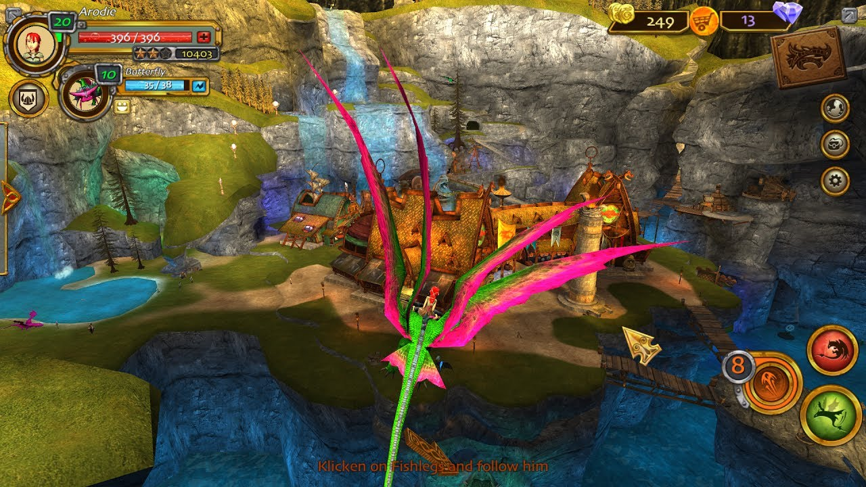

How do you plan to make your game engaging?

Adding new dragons and teach the players through the NPC TO how to ride the dragons ,so they can go to other island ,and make a world map so the player can go to different islands without flying using their dragons.